# Accessibility Guide for Self-catering Example

[Bob.Booker@Self-cateringExample.co.uk](mailto:Bob.Booker@Self-cateringExample.co.uk), [01452 123 456,](tel:01452%20123%20456) <www.Self-cateringExample.co.uk>

**Contact for accessibility enquiries: Bob Booker**

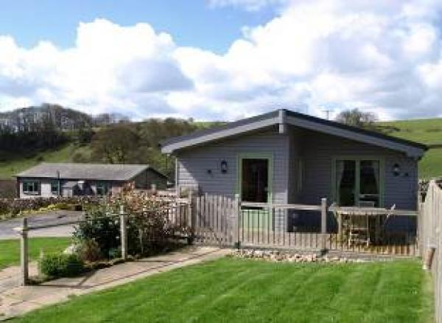

### Welcome

At Self-catering Example we want to make everyone's stay as enjoyable as possible, and are committed to providing suitable access for all our guests, whatever their individual needs. We aim to accurately describe our facilities and services to give you the confidence to book the right cabin for your specific requirements.

All our log cabins are rated by VisitEngland under the National Accessible Scheme.

Watch the video: [An example video](https://www.youtube.com/watch)

## At a Glance

### Level Access

* The main entrance has level access with a ramp. The ramp is permanent.
* There is level access from the main entrance to:
  + Bedroom: Twin bedrooms
  + Bedroom: Double Bedroom
  + Lounge
  + Lawn Area
  + Decking Area
  + Hot Tub

### Access with steps

* There are steps from the main entrance to:
  + Communal Garden

### Bedrooms

* We have non-allergic bedding.
* We have a portable hoist.

### Level access bedrooms

* From the main entrance to the bedroom, there is level access.
* The route to the bedroom is 750mm wide, or more.
* The bedroom door is 750mm wide, or more.
* There is unobstructed floor space 1200mm by 900mm, or more.
* The bathroom has a level access shower.

### Hearing

* The (bedroom) TVs have subtitles.
* We have a hearing loop in in the cabin..
* All staff have disability awareness and Next Generation Text training.

### Visual

* The walls and the doors have high colour contrast.
* We have information in large print and other.

### General

The accommodation is rated by the National Accessible Scheme as suitable for:

* Older and less mobile guests
* Part-time wheelchair users
* Assisted wheelchair users
* Visually impaired guests

M1 M2 M3a V1

* Staff are available 24 hours a day.
* All staff have disability awareness training.
* We have emergency evacuation procedures for disabled visitors.

## Getting here

5 The Road  
Town  
County  
SW1P3BT

#### Travel by public transport

* You can get to Self-catering Example by bus and train.
* The nearest bus stop is in Brassington. The bus stop is 3.1 miles / 5.0 km from Self-catering Example.
* The nearest train station is Derby. The train station is 11 miles / 17.7 km from Self-catering Example.

#### Travel by taxi

* You can get a taxi with Dovelin Cars by calling 07974665439. The taxi company has a wheelchair accessible vehicle.
* You can get a taxi with A Cabs - Buxton by calling 0129870423. The taxi company has a wheelchair accessible vehicle.
* We have a transfer service for visitors. We may be able to pick you up from the bus stop in Brassington.

#### Parking

* We have a car park. There are accessible parking spaces. The parking is less than 50 metres from the main entrance. Parking is free.
* There is a drop-off point at the main entrance. The drop-off point has a dropped kerb.
* From the car park to the entrance, there is level access. There is a permanent ramp.
* The route is 1080mm wide, or more.
* There is a dedicated tarmac parking space outside each cabin with ample room for unloading and manoeuvring.

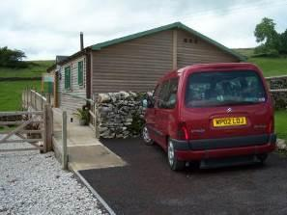  
Parking space adjacent to cabin

## Arrival

#### Path to main entrance

* From the street to the main entrance, there is level access.
* The path is 1080mm wide, or more.
* The path is sloped.

#### Main entrance

* The main entrance has level access.
* There is a permanent ramp.
* The door is 820mm wide.
* The main door is side hung and manual.
* When you arrive, we can help carry your luggage.

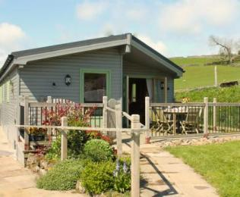  
Path to cabin entrance

## Getting around inside

#### Visual Impairment - General Information

* We have high colour contrast between walls and doorframes.

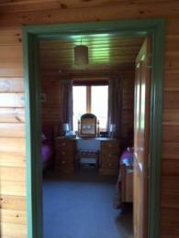  
Colour contrasting door frame

#### Bedrooms

* All bedrooms have windows.
* Bedrooms have ceiling lights, bedside lamps and natural daylight.
* TVs have subtitles.
* All bedrooms are non-smoking.
* We have non-allergic bedding.
* We can move the bedroom furniture, to improve accessibility.
* We have bed blocks.
* We have a portable hoist.
* From the main entrance to this area, there is level access.

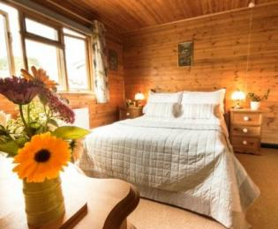  
Double bedroom

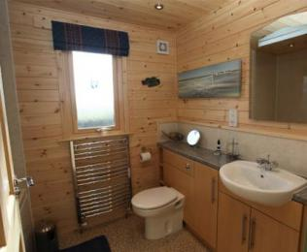  
Family bathroom

#### Accessible bedrooms

#### Accessible bedroom Twin bedrooms

* The route to the bedroom is 860mm wide, or more. The bedroom door is 860mm wide. There is 450mm at the side of the bed. The bed is 600mm high. There is 200mm under the bed.
* There is a low clothes rail. You can use the rail sitting down.
* The bedroom is flexible (either double or twin). The bathroom is ensuite. The bathroom door is 800mm wide.
* The bathroom has a level access shower. There is a shower chair available. The level access shower has handrails.
* The toilets have handrails. The direction of transfer onto the toilet is to the right. There is 870mm at the side of the toilet.
* There is 1000mm in front of the toilet. The toilet seat is 470mm high.
* The taps are lever operated. There is space under the basin, with no pedestal or boxing.
* The walls and the bathroom fittings have high colour contrast.
* The shower head can be lowered to 1300mm from the floor if required.   
  The basin is height adjustable from 690mm - 930mm.

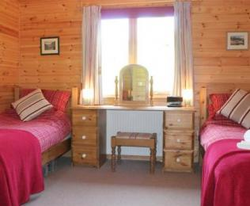  
Twin bedroom

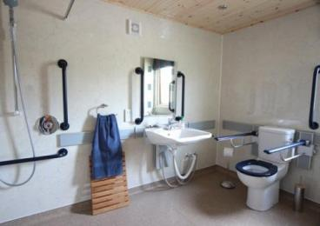  
Twin room ensuite wetroom

#### Accessible bedrooms

#### Accessible bedroom Double Bedroom

* The route to the bedroom is 860mm wide, or more. The bedroom door is 860mm wide. There is 450mm at the side of the bed. The bed is 680mm high. There is 300mm under the bed.
* The bedroom is flexible (either double or twin). The bathroom is separate. It is not an ensuite.
* The bathroom door is 800mm wide.
* The bathroom has a bath with an overhead shower. The shower has a handrail. There is a shower chair available. The direction of transfer onto the toilet is to the front only. There is 800mm in front of the toilet. The toilet seat is 410mm high.
* The basin is 860mm high. The taps are lever operated. There is no space under the basin.
* The walls and the bathroom fittings have high colour contrast.
* The bath edge is 610mm from the floor.

#### Self catering kitchen

#### Kitchen

* We have an open plan kitchen.
* From the main entrance to the kitchen, there is level access.
* The route is 820mm wide, or more.
* The door is 820mm wide.
* The work surface is available with clear underspace and available at a height between 650mm and 900mm.
* The hob is available at a height between 650mm and 900mm.
* The sink is available with clear underspace and available at a height between 650mm and 900mm.
* The oven is available at a height between 650mm and 900mm.
* The table and plates have high colour contrast.
* The crockery is kept in eye level kitchen units but can be moved to base units on request.  
  2 ring cooker for use on table available on request.

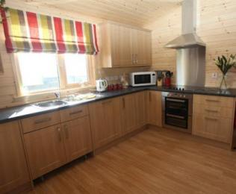  
Kitchen

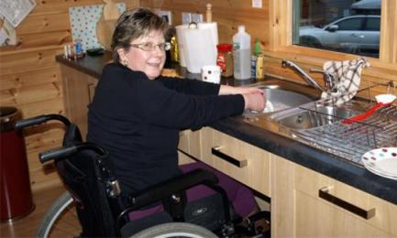  
Kitchen sink with clear underspace

#### Lounge

#### Lounge

* From the main entrance to the lounge, there is level access. The route is 820mm wide, or more. The door is 820mm wide.
* The lounge area is open plan with the kitchen.  
  There are two sofas, seat 460mm from floor and a high back armchair, seat 540mm from floor.

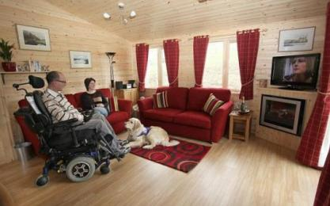  
Lounge

## Getting around outside

#### Communal Garden

* From the main entrance to the gardens, there are 2 steps. There is no lift and no ramp.
* The edges of both steps are highlighted in white.

#### Lawn Area

* From the main entrance to the gardens, there is level access.

#### Terrace

#### Decking Area

* From the main entrance to this area, there is level access. The entrance is 850mm wide.
* To get to a table, there are no steps.
* The table is 760mm high with clear underspace 660mm from floor to table edge.  
  Folding chairs have a seat height of 340mm.

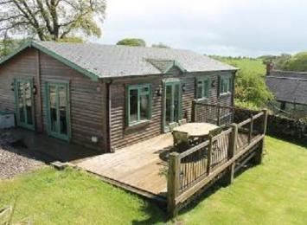  
Terrace

#### Hot Tub

* From the main entrance to this area, there is level access.
* There is a hoist available for accessing the hot tub.

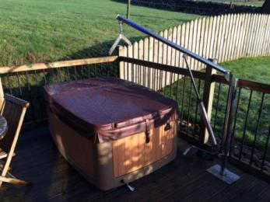  
Hot tub

## Customer care support

#### Accessibility equipment

* We provide wheelchairs. Wheelchairs are free.
* We have a hearing loop in in the cabin..
* We can provide an Oxford Advance mobile hoist; rise and recline armchairs; various shower chairs, toilet seat height raiser and bed blocks.
* The nearest toilet area for assistance dogs is located in the garden to the rear of the cabin.
* We have an area to charge mobility scooters and battery powered wheelchairs.
* We can charge a mobility scooter or battery powered wheelchair in our barn on request.
* You can hire mobility equipment from Arjo Huntleigh by calling 01234 555 666.
* You can hire mobility equipment from Clarke and Partners by calling 01234 666 777.

#### Emergency evacuation procedures

* We have emergency evacuation procedures for disabled visitors.

#### Customer care support

* All staff have disability awareness training.
* All staff have Next Generation Text training.
* We have information in large print .
* Visitor information is also available in Easy Read format.
* Staff are available 24 hours a day.
* Guest information files in cabins give details of local services and emergency procedures.  
  Mobile phone reception is variable depending on your network. A payphone is provided for emergency use in the farm house.
* We have other services for people with accessibility requirements.
* The mobile phone signal inside the cabins is variable; a coin-operated pay phone is situated in the conservatory outside the farmhouse for guest use (accessible 24 hours).

Guide last updated: 20 February 2020